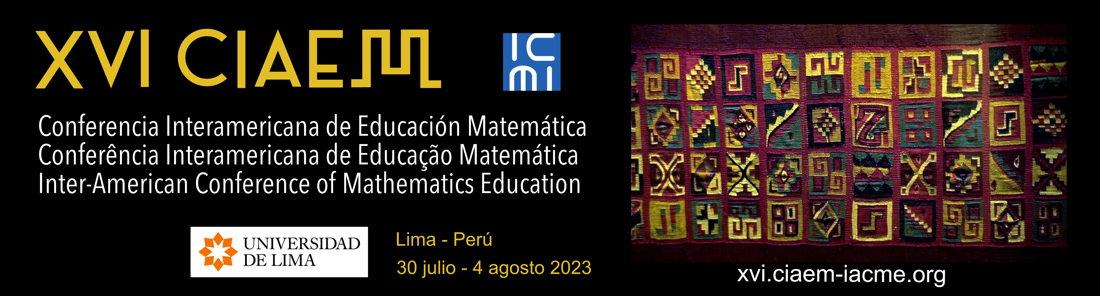

Write the title of the paper here

Abstract

It must be between 75 and 150 words, in the language of the presentation or, if you wish to add it in another language, you can also do so. The Abstract must be structured as follows, very briefly: introduction, which will include the objective or purpose of the research, methodology, and main findings or conclusions. You must place the name “Abstract” for each abstract you include (in the language of the Abstract) with lowercase, bold and centered. The font for the Abstract is the same as the main text. There should be a 1cm indent on both sides.

Below the Abstract, 5 to 10 keywords or short phrases (lexemes or descriptors) should be included. Follow the document called Suggestions for Keywords in IACME Style. Also use the same margins as the summary, that is: 1 cm on both sides. Put the word “Keywords” in italics, then a colon. The keywords which must be separated by semicolons.

Keywords: Mathematics education; Pre-university education; Virtual teaching; Curriculum implementation; Problem solving; Stochastics; Ministry of Public Education; Costa Rica.

These specifications assume many of the APA 7 style standards, but not all. For the publication of Proceedings and their graphic presentation, it is better not to assume the entire APA style. But the pertinent details are indicated below. You must use IACME Style.

Level 2 Subtitle

The open presentations can be Communications, Workshops or Posters. The invited presentations: Plenary talks, Parallel talks, Roundtables, Minicourses, Thematic Sessions, On D'Ambrosio.

Level 3 Subtitle

Level 4 subtitle. Gjhjlkñkñ

Tables

For tables use the following example as a guide:

Table 4
Teaching degree in mathematics. Credits and teaching hours.

University | Mathematics |  | Pedagogy |  | Other |  | Total
 | Credits | Hours | Credits | Hours | Credits | Hours | Credits | Hours
UNED | 59 |  | 27 |  | 12 |  | 98
UCR | 52 | 55 | 27 | 46 | 27 | 32 | 106 | 133
UMA | 54 | 63 | 30 | 36 | 14 | 16 | 98 | 115

Source: private survey. 2009.

Figures

In figures, drawings, images: put the title below:

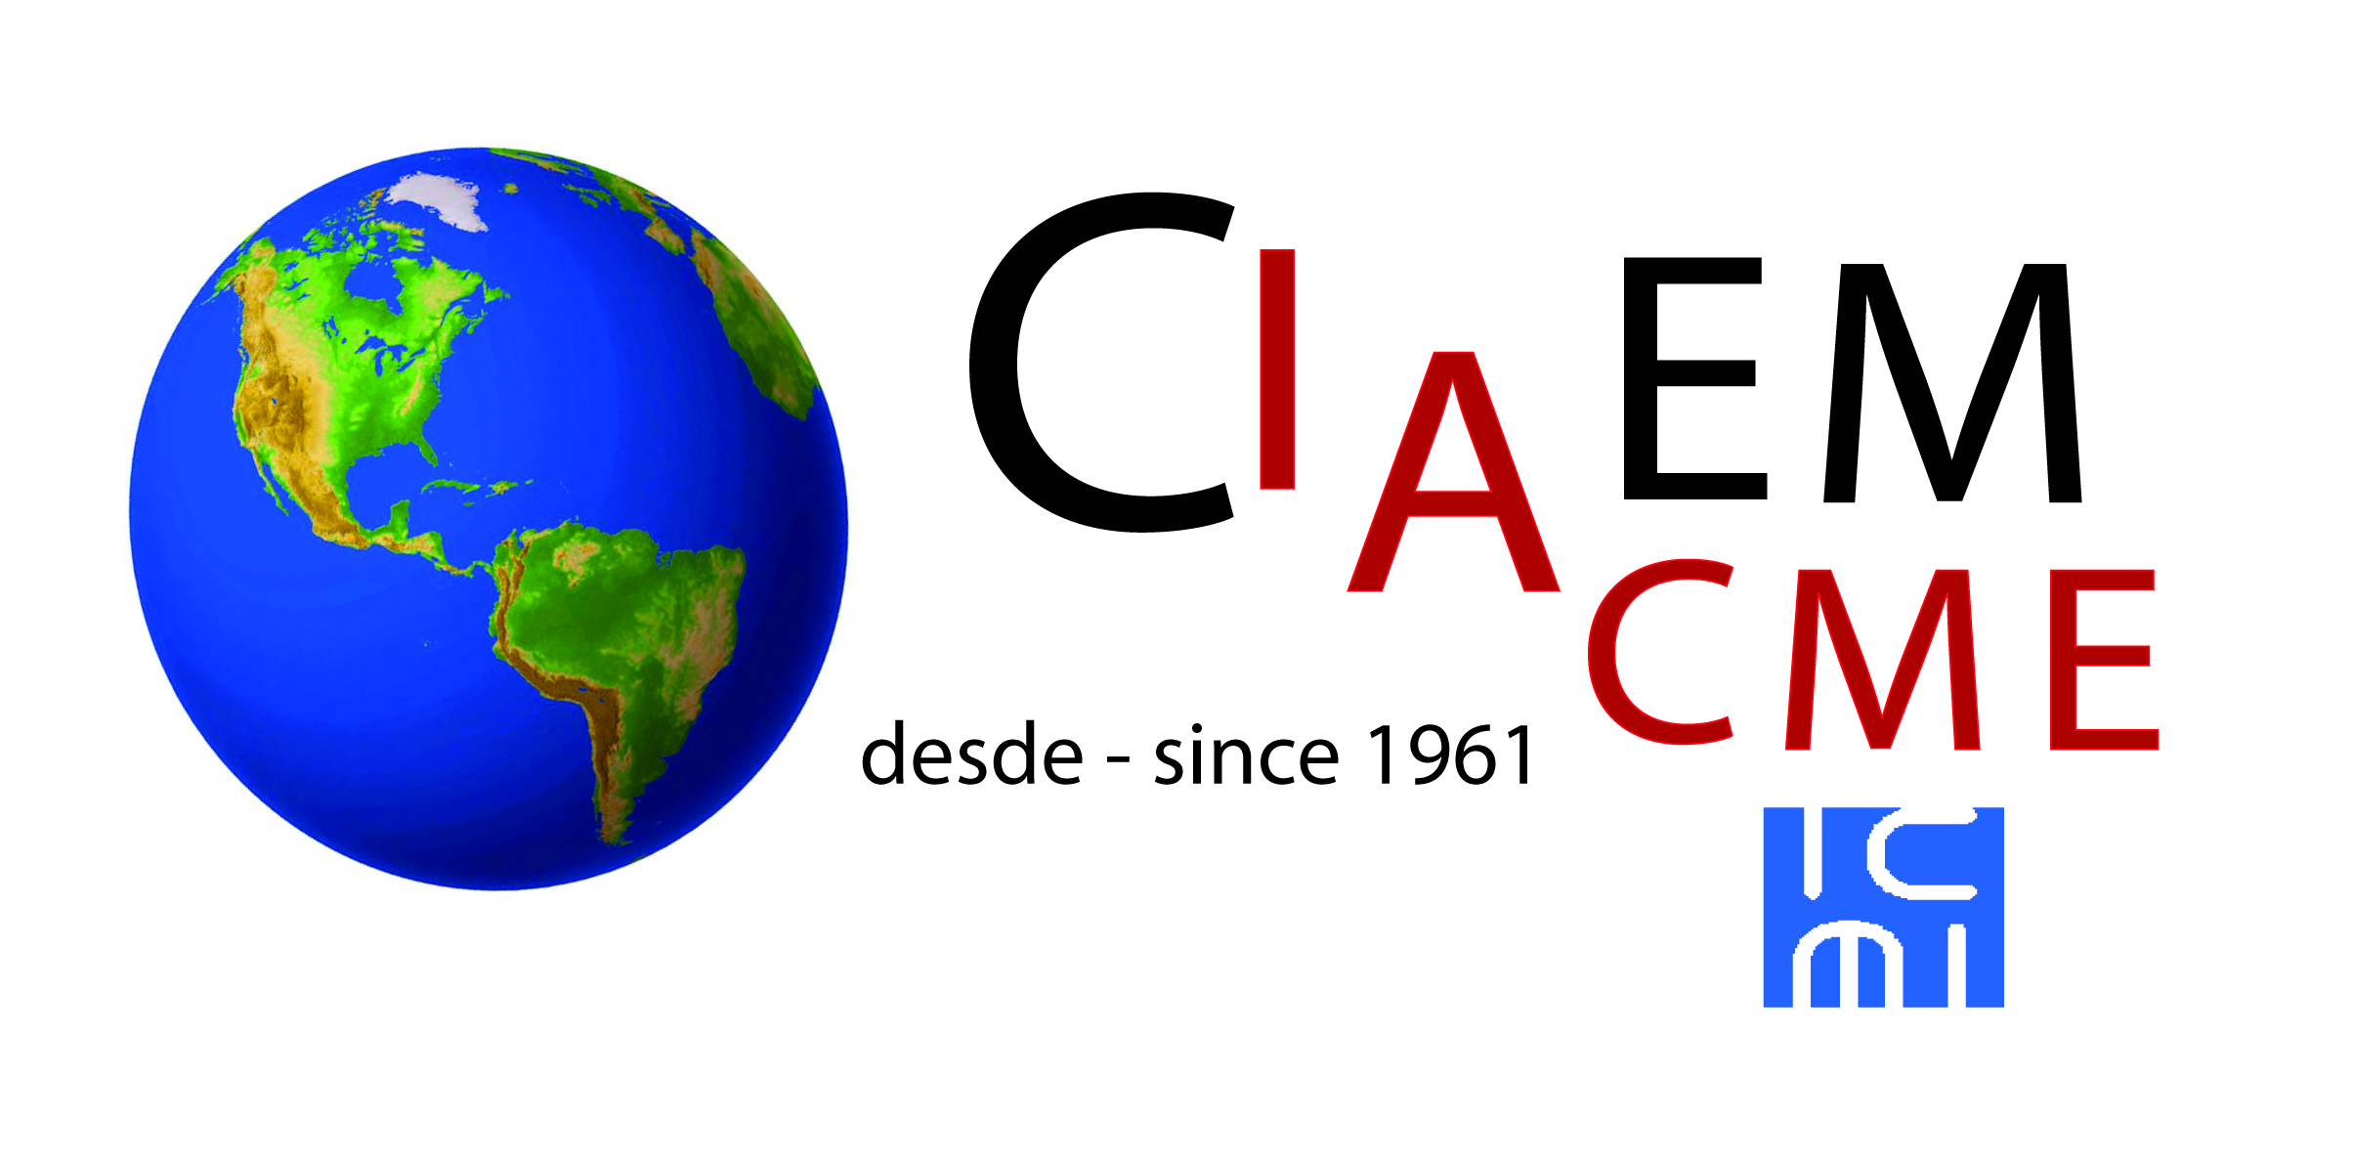

Figure 27. Small IACME logo.

References and bibliography

Tur Marí, J. A. y Pons Biescas, A. (2005). La alimentación en el mundo Púnico. En J. Salas-Salvadó, P. García Lorda y J. M. Sánchez Ripollés (Eds.), La alimentación y la nutrición a través de la historia (pp. 82–112). Glosa.
Barrientos-Fernández, A., Pericacho-Gómez, F.-J. y Sánchez-Cabrero, R. (2020). Competencias sociales y emocionales del profesorado de Educación Infantil y su relación con la gestión del clima de aula. Estudios sobre Educación, 38, 59–78. https://doi.org/10.15581/004.38.59-78

Bourguignon, R., Garaudel, P., & Porcher, S. (2020). Global framework agreements and trade unions as monitoring agents in transnational corporations. Journal of Business Ethics, 165(3), 517–533. https://doi.org/10.1007/s10551-019-04115-w

